PRACTICAL NO:04

PROGRAM:

#include<iostream>

#include<fstream>

using namespace std;

class employee{

char name[20];

int ID;

double salary;

public:

void accept()

{

cin>>name;

cin>>ID;

cin>>salary;

}

void display()

{

cout<<"\n Enter name:"<<name;

cout<<"\n Enter ID:"<<ID;

cout<<"\nEnter salary:"<<salary;

}

};

int main()

{

employee o[5];

fstream f;

int i,n;

f.open("gaurav.txt");

cout<<"\nHow many employee information do you need to store?";

cin>>n;

cout<<"\n Enter information of employee in this format(name/id/salary)";

for(i=0;i<n;i++)

{

cout<<"\nEnter inforamtion of:"<<i<<"\nEmployee";

o[i].accept();

f.write((char\*)&o[i],sizeof o[i]);

}

f.close();

f.open("gaurav.txt");

cout<<"\n information of employee is as follows:";

for(i=0;i<n;i++)

{

f.write((char\*)&o[i],sizeof o[i]);

o[i].display();

}

f.close();

return 0;

}

OUTPUT:

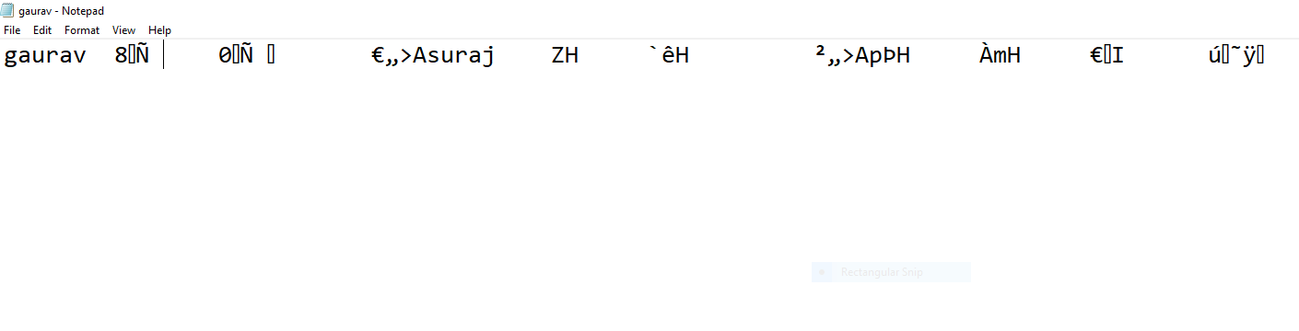

How many employee information do you need to store?2

Enter information of employee in this format(name/id/salary)

Enter inforamtion of:0

Employee

gaurav

28

2500000

Enter inforamtion of:1

Employee

suraj

32

63982

information of employee is as follows:

Enter name:gaurav

Enter ID:28

Enter salary:2.5e+006

Enter name:suraj

Enter ID:32

Enter salary:63982